[Lenar.io](https://www.lenar.io/)

Schedule Jenkins build periodically - hourly, daily, weekly. Jenkins schedule format

October 01, 2017 | [**Jenkins**](https://www.lenar.io/tags/jenkins/)

Under ***Build Triggers - Build periodically - Schedule*** you can create a schedule (or multiple schedules) for Jenkins to build periodically or on a specific date/time.

It might be tests that should be run periodically (every morning for example) or a DB clean up Jenkins job or any other Jenkins job.

To set periodically scheduled Jenkins jobs you should use ***Configure*** - ***Build Triggers*** - ***Build periodically*** - ***Schedule***

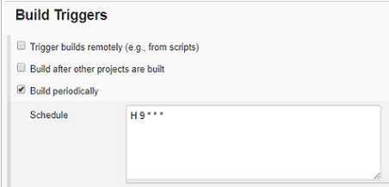

If you have many different Jenkins jobs that may need to be built periodically or by special schedules and limited resources I recommend to use *H* in every Jenkins schedule where it’s possible to avoid spikes.

Jenkins build periodically - examples

Build every hour:  
**H * * * \***

Build every 20 minutes:  
**H/20 * * * \***

Build every 20 minutes 2am to 11pm:  
**H/20 5-23 * * \***

Build every 20 minutes, work time/days (8am-6pm, MON-FRI) only:  
**H/20 8-18 * * 1-5**

Build every hour MON-WED and FRI only:  
**H * * * 1-3,5**

Build every hour, weekends in April and December:  
**H * * 4,12 \***

Build at 8.30am on July 4:  
**30 8 4 7 \***

Jenkins schedule format

Jenkins schedule format is nothing but a cron schedule expression. It contains 5 fields

┌───────────── minute (0 - 59)

│ ┌───────────── hour (0 - 23)

│ │ ┌───────────── day of month (1 - 31)

│ │ │ ┌───────────── month (1 - 12)

│ │ │ │ ┌───────────── day of week (0 - 6) (Sunday to Saturday;

│ │ │ │ │ 7 is also Sunday on some systems)

│ │ │ │ │

│ │ │ │ │

* * * * * schedule command to execute

*Note: Taken from*[*Cron*](https://en.wikipedia.org/wiki/Cron)

Jenkins build periodically - predefined aliases

Jenkins also supports predefined aliases to schedule build: *@hourly*, *@daily*, *@weekly*, *@monthly*, *@midnight*

| **Schedule Alias** | **Schedule Description** | **Schedule command** |
| --- | --- | --- |
| *@hourly* | Build every hour at the beginning of the hour | 0 * * * * |
| *@daily*, *@midnight* | Build every day at midnight | 0 0 * * * |
| *@weekly* | Build every week at midnight on Sunday morning | 0 0 * * 0 |
| *@monthly* | Build every month at midnight of the first day of the month | 0 0 1 * * |

Jenkins build periodically - multiple schedules

You can apply even more than one schedule for a Jenkins job.

For example you might have a regular schedule to build Jenkins periodically, let’s say we want to build periodically every work day’s like this  
**30 8 * * 1-5**

Let’s assume we need to build Jenkins periodically every week before weekend starts.  
**30 16 * * 5**

Now we can easily combine these two Jenkins schedules

**30 8 * * 1-5  
30 16 * * 5**

Jenkins will build every work day at 8:30am and every week on Friday at 4:30pm

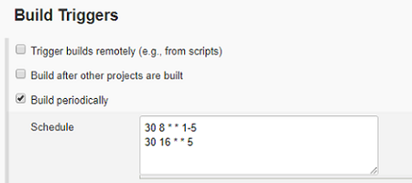

You may also find these posts interesting:

* [How to set Jenkins Extended Choice Parameter from service call](https://www.lenar.io/jenkins-extended-choice-parameter-from-service-call/)
* [Jenkins - custom build name](https://www.lenar.io/jenkins-custom-build-name/)

© 2016-2019 [www.lenar.io](https://www.lenar.io/)